**Ideation Phase**

**Define the Problem Statements**

|  |  |
| --- | --- |
| Date | 19 September 2022 |
| Team ID | PNT2022TMIDxxxxxx |
| Project Name | Project - xxx |
| Maximum Marks | 2 Marks |

**Customer Problem Statement Template:**

Create a problem statement to understand your customer's point of view. The Customer Problem Statement template helps you focus on what matters to create experiences people will love.

A well-articulated customer problem statement allows you and your team to find the ideal solution for the challenges your customers face. Throughout the process, you’ll also be able to empathize with your customers, which helps you better understand how they perceive your product or service.

Reference: <https://miro.com/templates/customer-problem-statement/>

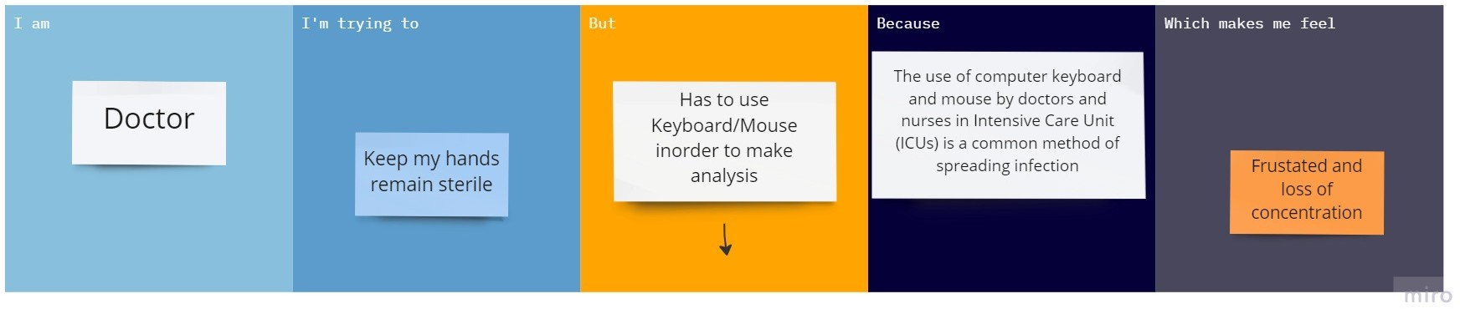

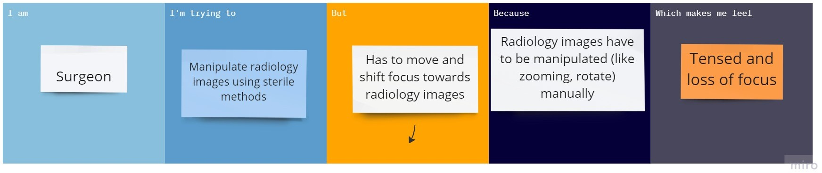

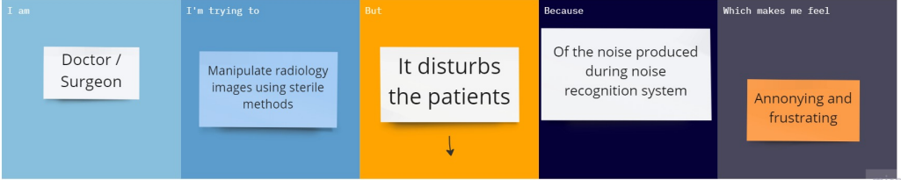

|  |  |  |  |  |  |
| --- | --- | --- | --- | --- | --- |
| **Problem Statement (PS)** | **Iam (Customer)** | **I’m trying to** | **But** | **Because** | **Which makes me feel** |
| PS-1 | Doctor | Keep my hands remain sterile | Has to use Keyboard/Mouse inorder to make analysis | The use of computer keyboard and mouse by doctors and nurses in Intensive Care Unit (ICUs) is a common method of spreading infection | Frustated and loss of concentration |
| PS-2 | Surgeon | Manipulate radiology images using sterile methods during surgery | Has to move and shift focus towards radiology images | Radiology images have to be manipulated (like zooming, rotate) manually | Tensed and loss of focus |
| PS-3 | Doctor/Surgeon | Manipulate radiology images using sterile methods | It disturbs the patients | Of the noise produced during noise recognition system | Annonying and frustrating |